Kubernetes Pod
In Kubernetes, a Pod is the smallest and simplest unit that you can create or manage.
It represents a running instance of one or more containers (like Docker containers) in your cluster.
Smallest deployable unit
- Kubernetes doesn’t run containers directly — it runs Pods.
- A Pod wraps one or more containers that share the same network and storage.
Shared resources inside a Pod
- All containers inside the same Pod:
  - Share the same IP address
  - Can communicate with each other using localhost
  - Share the same volumes (for file sharing)
Usually one container per Pod
- Most Pods run a single container, but you can have multiple if they’re tightly coupled (e.g., a web server and a logging sidecar).

Objective:
Practice basic kubectl commands to manage Pods.

Step 1: Create a Pod
Create a simple Pod YAML file named my-pod.yaml.
apiVersion: v1
kind: Pod
metadata:
name: my-pod
labels:
app: nginx
env: dev
spec:
containers:
- name: nginx-container
image: nginx:latest
ports:
- containerPort: 80
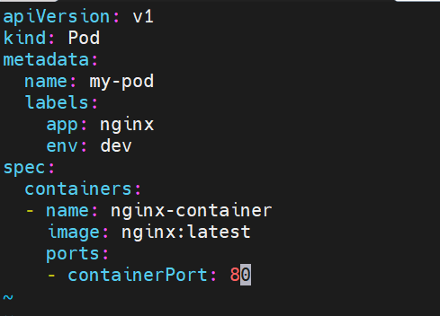

👉 Apply the YAML:
kubectl apply -f my-pod.yaml
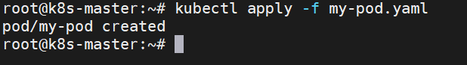

Step 2: List Pods
List all Pods in the current namespace.
# kubectl get pods
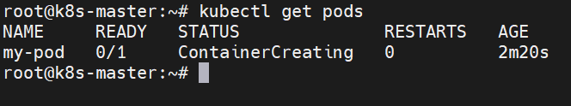
List Pods with detailed (wide) information (shows Node name, IP, etc.):
# kubectl get pods -o wide
List Pods with their labels:
# kubectl get pods --show-labels
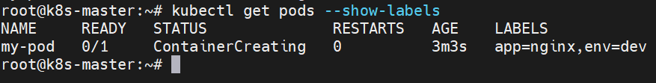

Step 3: Filter Pods Using Labels
Get Pods with a specific label:
kubectl get pods -l app=nginx
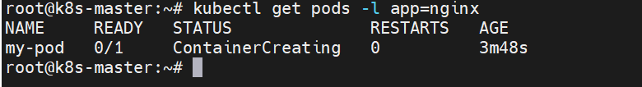
Add a new label to the Pod:
kubectl label pod my-pod version=v1
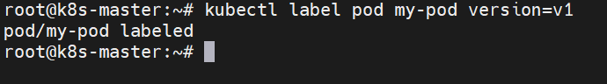
Verify:
kubectl get pods --show-labels
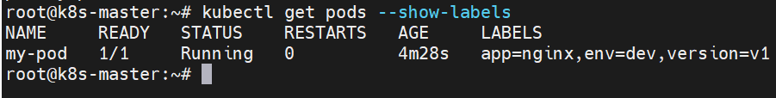

Step 4: Describe the Pod
View detailed information about the Pod (events, containers, IP, etc.):
kubectl describe pod my-pod
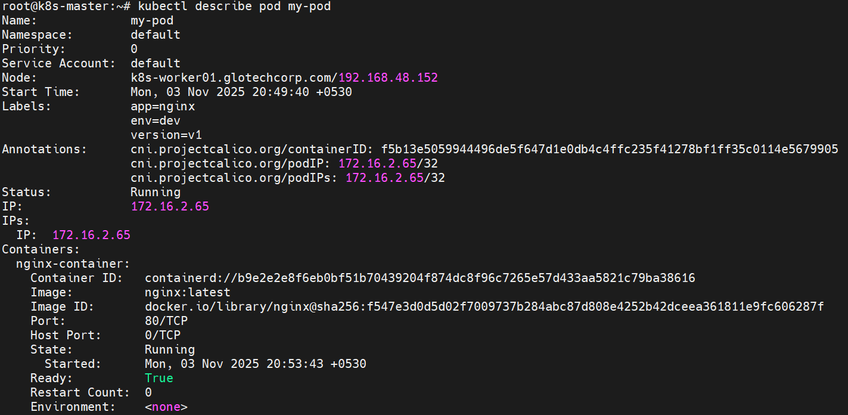

Step 5: View Pod Logs
Check the logs of the container running inside the Pod:
kubectl logs my-pod
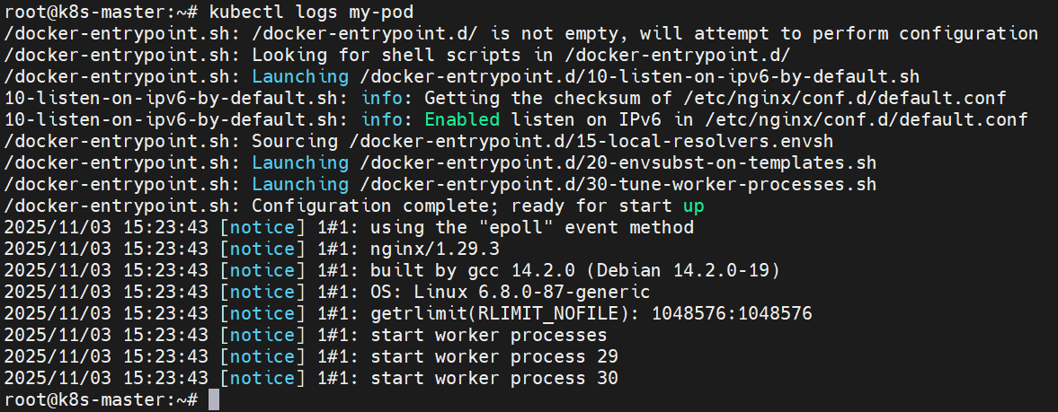
If there are multiple containers (example: nginx-container), specify it:
kubectl logs my-pod -c nginx-container
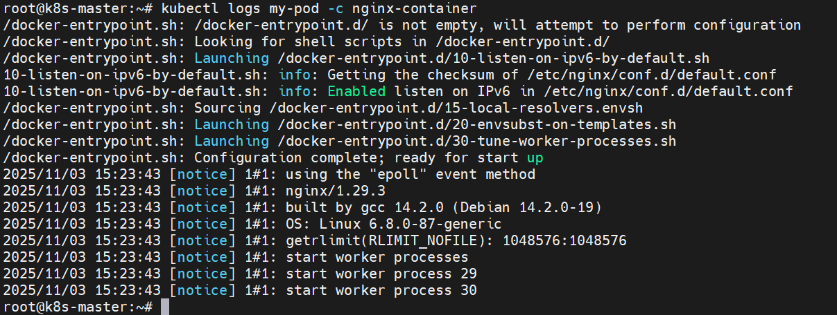

Step 6: Access Pod (Optional)
Run a command inside the Pod (e.g., check Nginx default page):
kubectl exec -it my-pod -- /bin/bash
Then run:
curl localhost
exit
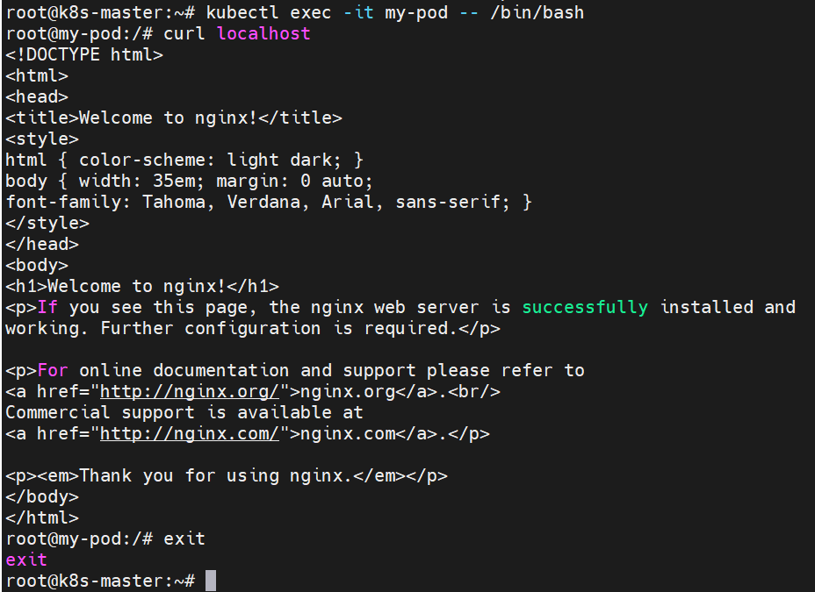

Step 7: Delete the Pod
Delete the Pod using either command:
kubectl delete pod my-pod
Or delete from YAML:
kubectl delete -f my-pod.yaml
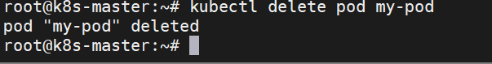

✅ Lab Validation
- Pod created successfully
- Pod visible in kubectl get pods -o wide
- Labels added and verified
- Pod described successfully
- Logs retrieved successfully
- Pod deleted successfully
===========================================================================
Revision:
You can manually schedule a pod on a specific node by specifying the nodeName field in the Pod specification. When a nodeName is given, the Kubernetes scheduler is bypassed and the pod is directly assigned to run on the node with the given name.
Here is an example Pod spec with nodeName:
apiVersion: v1
kind: Pod
metadata:
name: manually-scheduled-pod
spec:
nodeName: specific-node-name
containers:
- name: my-container
image: my-image
In this YAML:
- nodeName is set to specific-node-name, which is the name of the node where you want to schedule the Pod.
- name in containers is the name of your container.
- image in containers is the Docker image of your container.
You would save this YAML in a file (say pod.yaml) and create the Pod using:
kubectl apply -f pod.yaml
Please note that specifying a nodeName in the Pod spec is a form of direct pod scheduling. It bypasses the Kubernetes scheduler which means it does not take into account the various sophisticated scheduling features like resource-based scheduling, affinity and anti-affinity, taints and tolerations etc.
It's typically best to let Kubernetes automatically handle scheduling so it can balance resources across all nodes in the cluster. Manual scheduling is generally used for specific scenarios where you need fine-grained control.

